Week9 DOE, Advanced Probability Distribution

# Agenda

DOE( design of experiments)

multi-armed bandit models,

probability distributions that are useful for modeling real life situations.

prescriptive analytics( probability-based models and techniques)

# links:

binomial : [Business Analytics: Case Study for Binomial Distribution - Bing video](https://www.bing.com/videos/search?q=use+case+of+binomial+distribution&&view=detail&mid=0270945D3AF0379D3D180270945D3AF0379D3D18&&FORM=VRDGAR&ru=%2Fvideos%2Fsearch%3Fq%3Duse%2Bcase%2Bof%2Bbinomial%2Bdistribution%26FORM%3DHDRSC4)

Summary : [Probability Distributions and use cases | Practical Machine Learning (udibhaskar.github.io)](https://udibhaskar.github.io/practical-ml/probability/distribution/bernoulli/binomial/normal/poission/geometric/lognormal/2020/06/05/Distributions.html#Poisson-Distribution)

**Definitely CHECK:** [Uses of Probability Distributions | Towards Data Science](https://towardsdatascience.com/6-useful-probability-distributions-with-applications-to-data-science-problems-2c0bee7cef28#:~:text=Exponential%20distribution%20can%20be%20used%20as%20an%20anomaly,is%20as%20a%20simple%20benchmark%20for%20predictive%20models.)

# 9.1.Introduction to DOE

**Assumption until now:**

1. we already have data. difficulty is building the right analytics model to discover something from the data.
2. we assume that data can easily be collected.

**some situation:** collecting data is not possible or take too long

[1]

**Workaround:**

* design a way to try to collect the best subset of data we can get, quickly and efficiently.
* when collecting that data, we have to make sure that the data will answer the questions

That design process is called design of experiments or DOE.

**Examples:**

1. **GT banner ad**

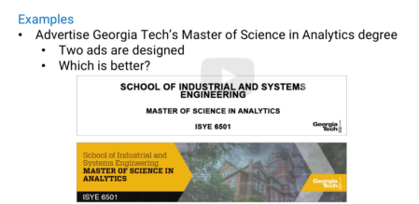

1. Online retailer- search on retailer , we might not give us what customer need, but they want to give suggestion of something to make the customer buy

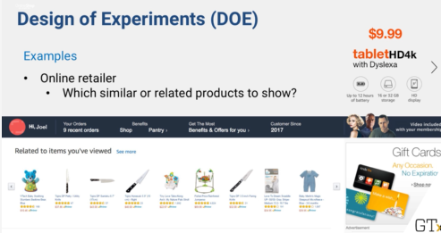

(or) if you buy the products, what complementary products that customers can buy?

1. E.g.3 polical poll – need wide demographics of people

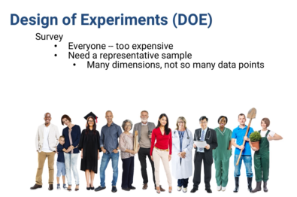

More examples:

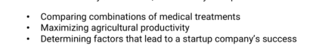

## 9.1.2 concepts of DOE

### Compare and Control

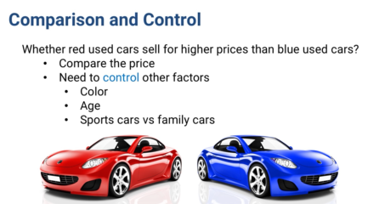

* While comparing cost , we also need to control external factors (e.g 2 year old proche vs. 10 year blue family car)
* **Suggestion:** controlling for the effects of color, and car type.

1. need to make sure the two data sets have the same mix,
2. or we need to break down the data in to smaller sets, that test all of the factors, not just color.

### Blocking

A blocking factor is something that could create variation.

* Say, red cars are most likely to be sports car
* If we account for that difference, we can reduce the variability in our estimates.
* **Workaround:** Create different set to analyze red family cars and red sports cars. This will have lower variance than analyzing all red cars together

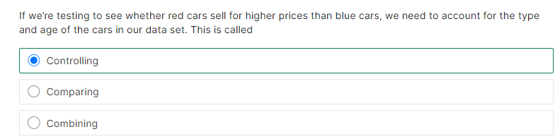

# 9.2 A/B testing

**Agenda:** how to use analytics to pick the best out of several alternatives?

**Example:** Banner ads on websites(sometime 2 different banner ads for same)

How do they decide which ad to go?

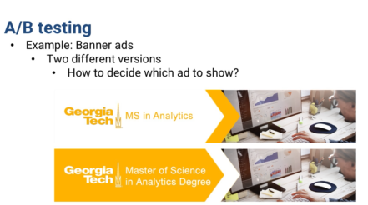

* Collect data by using both ads for the first “2000” times the ad is shown
* Each time we randomly pick ad#1 or ad#2
* Track how often the ads are clicked
* We will have binomial data for each ad
* Use hypothesis testing to pick one

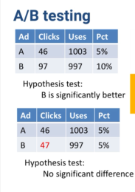

**Other option:**

-no need to run “2000” times. We can do even “10” times and if we see the results get extreme enough to make a decision of which optionis better

**Requirement of A/B testing:**

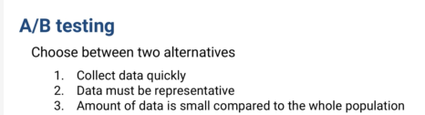

**#3:** if 2000 users are present ,we cannot use 1000 for testing..because we cannot benefit much

**Adv:**

1)test which option is better

2)common approach used in marketing

**Disadv:**

1. only 2 options
2. waste our benefits by test on bad approach (if we want to learn from trails and use to our benefit)
3. combination of factors to see which combination works best is not possible

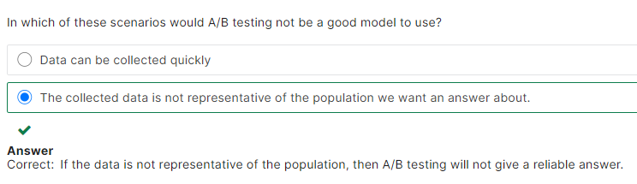

# 9.3 Factorial design

**Agenda:** combnation of factors that yield better results

**Sample:**



* ad of the left has more clicks. Why is that?
* How important are the differences. To answet this, use “**Full Factorial design”**

## Full Factorial testing:

ANOVA : Analysis of variance – determine how much each factor contribute to difference in each combination

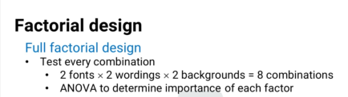

**Challenge**: we have 8 combination..what if we have more

e.g 7 different factor and each have 3 possible factors : which makes 3 to the power 7=2187 combination

## Fractional Factorial Design

So rather than “FULL” factorial, we use subset of combination of test. This is called “Fractional Factorial Design”

-use few combination, but good range of value to test

**Sample**

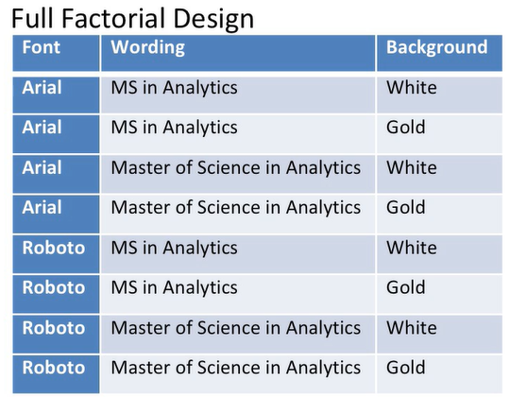 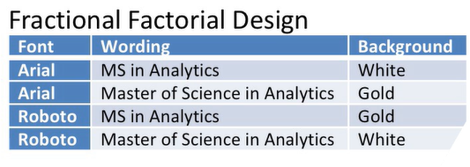

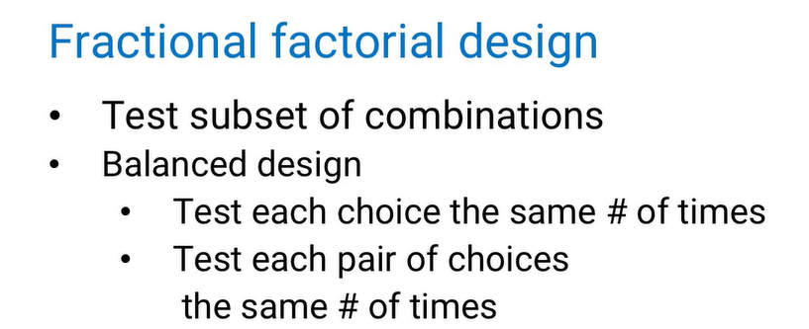

This is called **BALANCED DESIGN (**eachtesting pair of choices and choices appear same number of times)

i.e..arial+white combo appear once, as does “roboto+ms. In analytics”

**Adv:**

1. For more complicated experiments with more factors and more choices, it's still possible to create good designs, good sets of combinations to test.

## Independent Factors

* **When**? Applies when factors we can change are independent
* **How?** test a subset of combinations and then use **regression** to estimate the effect of each choice.
* Each factor will get its own categorical variable . say, one variable for background color and one for font color
* Based on each of the factors that makes up every combination, we could use regression to estimate the number of clicks as the response.
* **adv:** If there aren't significant interactions between the factors,then this could work well. We can include few interaction terms depending on factor interaction

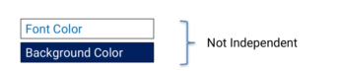

There are more advanced approaches

Say, **response surface methodology** is similar to a factorial design, but it allows for squared terms as well as linear terms when running the tests.

* All above used when they're used before modeling and even before collecting data.
* If you're in the position to decide what data to collect and what comparisons to try, factorial design can be a powerful tool.

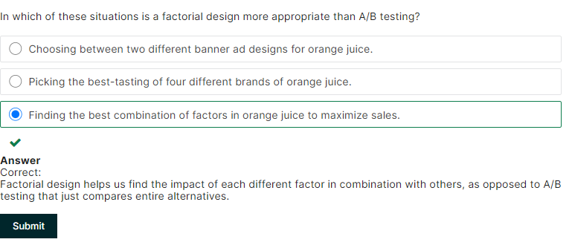

# 9.4 Multi-Armed Bandits

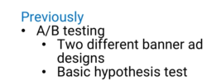

What if we have more than one alternative? Run each alternative “x” number of times and run statistical test to compare results

**Challenges with the above (LOSING VALUE):**

* Each time we do one of the tests, we might be losing value.
* Let's say there were ten different alternatives, and we tested each one a thousand times. And number one turned out to be the best.
* So the thousand times we tested alternative number one,we were showing the best ad.
* But the other 9,000 times, we were showing an ad that wasn't the best.

So we probably **lost value**.

* Had we shown them number one, we would have gotten more people clicking on our ad.
* So there's a tradeoff
* Every time we're presented with an opportunity to show an ad, we have to balance the benefits of getting more information, and getting immediate value.

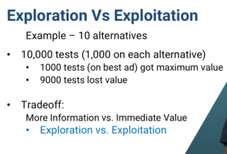

## Exploration and exploitation

-Two types of benefits

**Exploration** : that we 're focusing on getting more information, in this case to determine with more certainty which ad is really the best.

**Exploitation**: that we're focused on getting immediate value. In this example, to show the ad that seems to be doing best so far, because it seems to be most likely to be clicked.

Exploration vs. Exploitation sort of problem is called the Multi-Armed Bandit problem.

## One Armed bandit: Why this name?

**Origin:** gambling, specifically slot machines.

* In a slot machine, you put money into a slot and pull a lever.
* A slot machine is sometimes called a one armed bandit.
* One armed because a little lever that sticks out like an arm.
* Bandit because the probabilities of winning and the amount you can win are carefully calibrated to give the player a negative expected value(On average, you'll lose money )

## Multi Arm bandits

suppose there were several slot machines next to each other, each with a different expected payout that we don't know.

A slot machine player would want to play the one with the highest expected payout .Only way to find out which has the highest payout is to test them all.

## How multi-armed bandit approach works?

There are different variations, but they all work something like this.

Example:

-we're testing K alternatives, we start without any information.

i.e each alternative seems to have equal probability of being best.

1st test we have an equal probability of selecting each alternative.

After performing some tests, we've gotten more information, we can update the probabilities of each one being best.

And start assigning new tests according to those probabilities for future tests

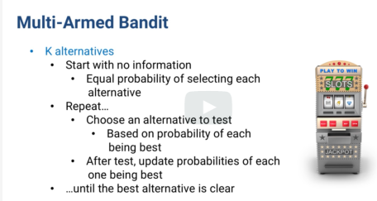

1. We keep testing multiple alternatives, so we're still doing **exploration** (repeat, collect data, update probabilities)
2. But we make it more likely to pick the best ones, so we're also doing **exploitation**. (more likely to pick the options with higher estimated value)

**Parameters change**

- change the number of tests between recalculating probabilities.

- change the way we update the probabilities( using Bayesian updates, or estimate from the observed distributions.

- change how we assign new tests.(just looking at probabilities of each alternative being best, or taking into account the expected value of each)

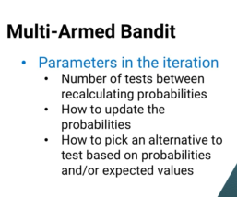

**Adv:**

* it usually works much better than running a fixed,large number of tests for every alternative.
* Multi-armed bandit models both help you learn faster on the fly, and also create more value along the way

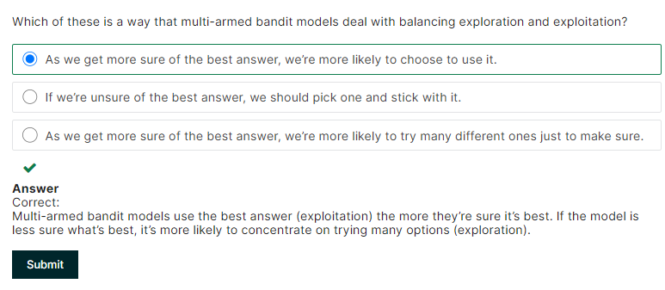

# 9.5 Introductions to Advanced probability Distributions

-under appreciated tools => probability distributions

**Suggestion**: rather than taking big data and fit to a model, try simple approaches

**Examples:**

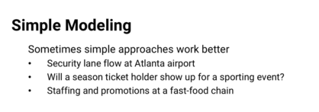

**Detail example:**

-predicting who will not show up for season ticket to sell the ticket as an upgrade

Purpose:

1. Create profit without impacting customer experience

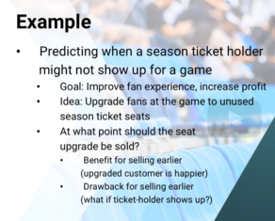

**Tradeoff**: if sold too early, original ticket buyer will be unhappy. So they want to allote a new seat when they see in bar scanner that the original buyer showed up for the gaming event

We are dealing with unknown here..people who havennt responded that they will come or not.

**Factors:**

Many factors:climate,city of gaming,. Age, marital status, past data how frequently in past they missed, curciality of game, popular of game..etc

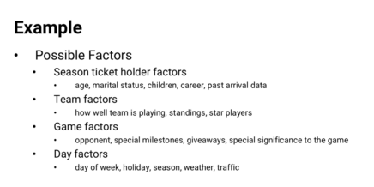

-lot of data to collect.

BUT, they are all IRRELEVANT

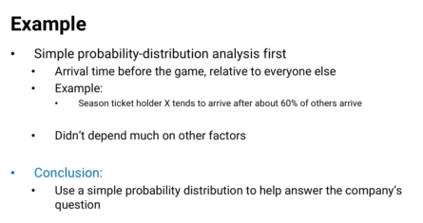

More examples:

* Arrivals to security lines at an airport.
* Broken equipment in a manufacturing facility.
* Website viewers who buy products they've clicked on and more.

# 9.6 Bernoulli, Binomial, geometric distributions

**When more helpful ?**

when only info , we have about data is the response

hard to collect data

## 9.6.1 Bernoulli

Probability “p” that the coing comes up head and (1-p), it is a tail

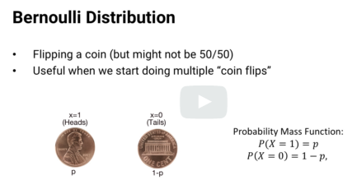

**Useful:** modeling a single event

**Examples:**

1. Will it rain or not?
2. Will I get a job or not?

*By itself,not so useful. because it's only talking about one data point.

*Where the Bernoulli Distribution gets useful,is when we put many of them together.

## 9.6.2 BINOMIAL

**Example:**

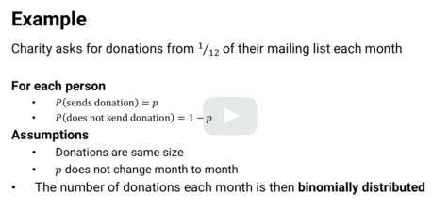

-each donation are **independent of each other**

-assumption that “p” number of donation every month is same. If not, charity will not have enough cash flow for that month

-to test this assumption, they get data of how many donations they get every month

-binomial distribution finds probability of getting the same number of donations (similar to no preference between orange or grape fanta)

-if probability is low, which means “p” for that month is different than other months

BINOMIAL : probability of getting “x” answers in independent “n” bernolli trials is called BINOMIAL distribution

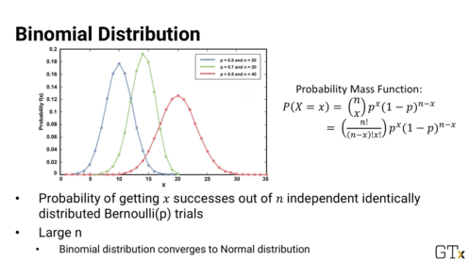

**-use of binomial** : it is used widely in hypothesis testing

- when “n” gets large, binomial distribution changes to “NORMAL” distribution

-normal distribution is very useful in predicting errors

(my notes) To model what to expect when there is no preference. If model is poor fit, then we reject the hypothesis that both options are equally liked/no preference

## 9.6.3 GEOMETRIC Distribution

Another type of Bernoulli-related question that comes often is,

How many trials are needed before we get an answer of a certain type?

**Example:**

1) how many interviews do you need to go on before getting your first job offer?

2) how many of our Masters in Analytics students does a company need to make an offer to before one of you accepts that offer over the others you've gotten?

3) How many hits does a baseball bat last through until it breaks?

4) How many times does a manufacturing process create working units before a defective one is made?

This type of distribution is called the **geometric distribution.**

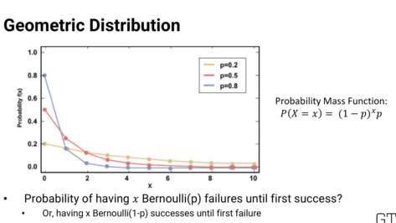

“p” => probabltty of getting the answer we are looking at the end

P => may be probability of good outcomes, like job offer and (1-p) is bad outcome

Something, “p:” may be bad outcome, like bat breaking/defective unit and (1-p) is good outcome before that bad outcome happened

*careful with understanding what is “p” and what is (1-p)

**#2 usage:** In addition to answering “how many” question, we can also use geometric to **compare data to test whether it is independent and identically distributed(i.i.d)**

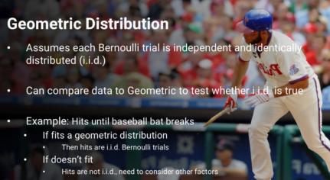

**Another example:**

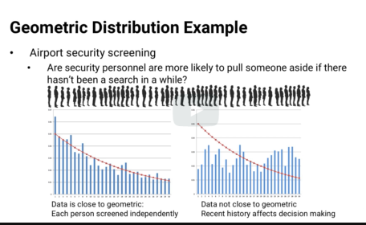

**Human hardwire to do in security screening:**

If many people are taken aside , then security will let few pass or vice versa…we want to see if screeners are doing the same ..

We take the data before the person is pulled aside and see it the data fits geometric distribution. If it fits, we know the screeners are working as expected and that the data is independent indentical data (i.i.d)

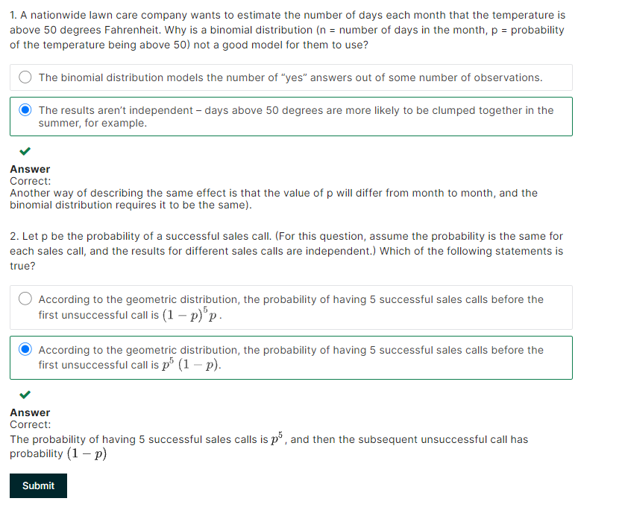

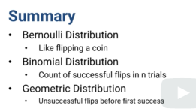

# 9.7 Poisson, Exponential and Weibull distributions

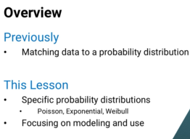

## 9.7.1 Poisson distribution

**Good**: modeling random arrivals of people in lines or queues of call in call center

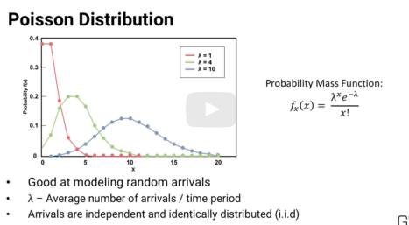

- lambda => average number of arrivals in a time period.

The function gives the probability that x people do arrive given the average arrival rate lambda.

The Poisson model assumes that the arrivals are independent of each other and have the same distribution.

independent and identically distributed or i.i.d..

## 9.7.2 Exponential distribution

-complementary to Poisson

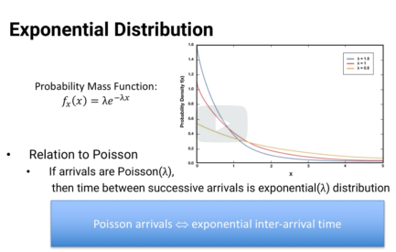

* **with one over lambda as the average inter-arrival time.**
* This goes other way too (if inter arrival is exponential with average inter arrival time as 1 over lamba, then arrival is poisson with lamda as average arrival per unit time)

Example2:

* Instead of trying to count passenger arrivals in a time period, it was much easier for students to click their stopwatch every time a new passenger showed up abd subtract from the previous passenger's time to determine how long it was between their arrivals.This gave inter arrival time which was exponential..using this the complementary was possion , we can get arrival time

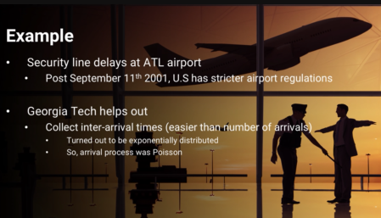

## 9.7.3 Weibull distribution

- used in modelling the amount of time it takes something to fail, specifically the time between failures.

* similar to the geometric distribution . except that the geometric counts **how many trials** there are between failures,

while the Weibull tracks **how much time** there is between failures.

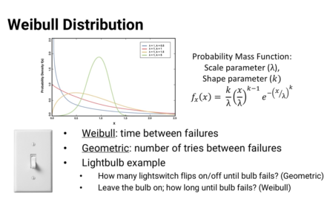

**Example:**

how many times you can flip your light switch on and off before the switch breaks, that's geometric.

But if you want to keep the light on all the time, and you're wondering how long the bulb will last before it blows, that's Weibull.

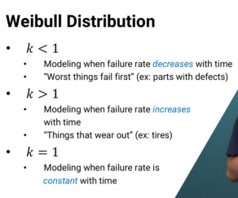

K<1 : (when failure rate decrease with time)

Example: mechanical parts ..with defects fail first

*Note: when k=1, it reduces to exponential equation (with substituting lamba with 1 over lamba )

*Whether it's a failure rate that's constant over time, or an enter arrival rate that's constant over time, the two distributions give the same results.

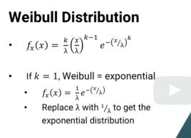

**About Software:**

Can provide

-what the best fit parameters are, for example what the most appropriate value of lambda is to use in a Poisson distribution.

- fit your data to many different distributions at the same time and let you know which ones it fits well.

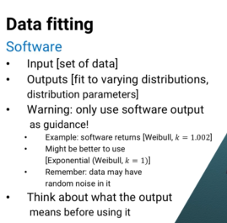

-if arrival fit exponential, but software tells it is weiball because k value = 1.002 ..so software considers better fit..

However this could just be random noice..so think before deciding on the solution that software provides

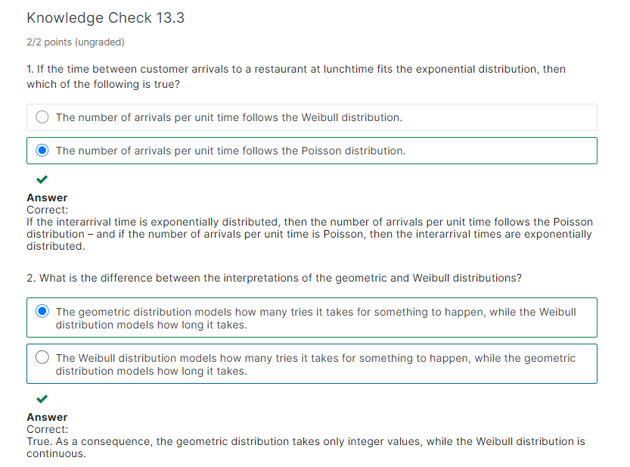

# 9.8 Q Q plot

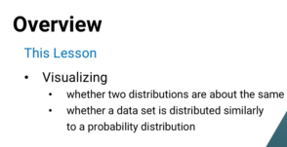

Why viz is preferred to statistical test:

1. statistical test can hide some factors like what happens in upper and lower bounds/specific areas of deviation of data set from the probability distribution

**idea:**

no matter how many data points are in two set, if they are similarly distribution, they will have same value in each quantile

To compare two dataset, we can plot, 50th percentile of one data set against 50th percentile of other data set

Left is Good match

Right is not good match..on low end of the value, 2nd data set have high value and on high end value, again 2nd data set have high value

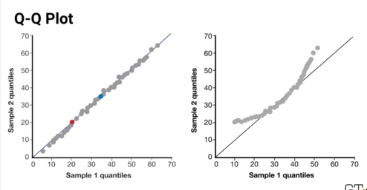

Statistical test can give us same results

-but q-q plot, helps us qualitatitvely understand the data

-also stat. test doesn’t give us extra insight on lower and upper tails

In samepl below

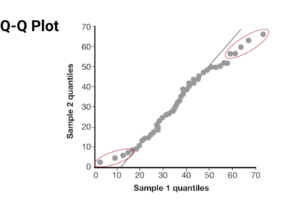

-a stat test will tell us it’s a good match.

But if we focusing on studying lower and upper tail data, we know that it might not be good match

**Scenario#2: use q-q plot**

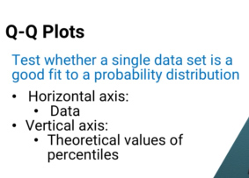

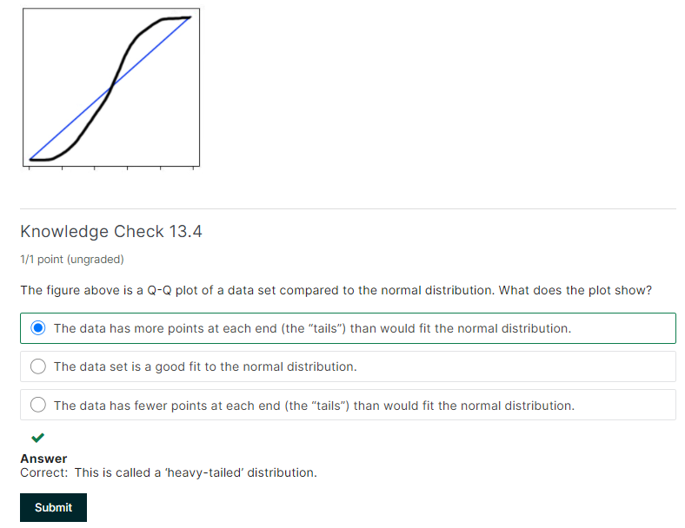

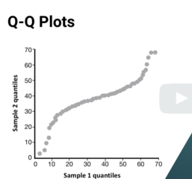 **In this graph, the data is squeezed towards the center**

# 9.9.Queuing

**Agenda:** If we know something fits a probability distribution, what more can we do to model its behavior?

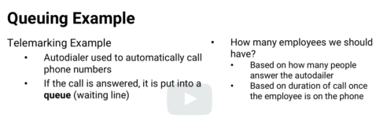

-we can analyze the above scenario as “queueing” system

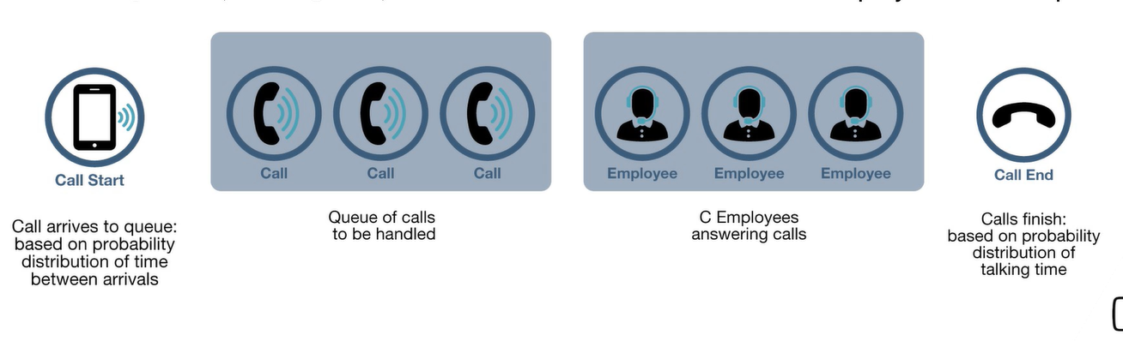

For example:

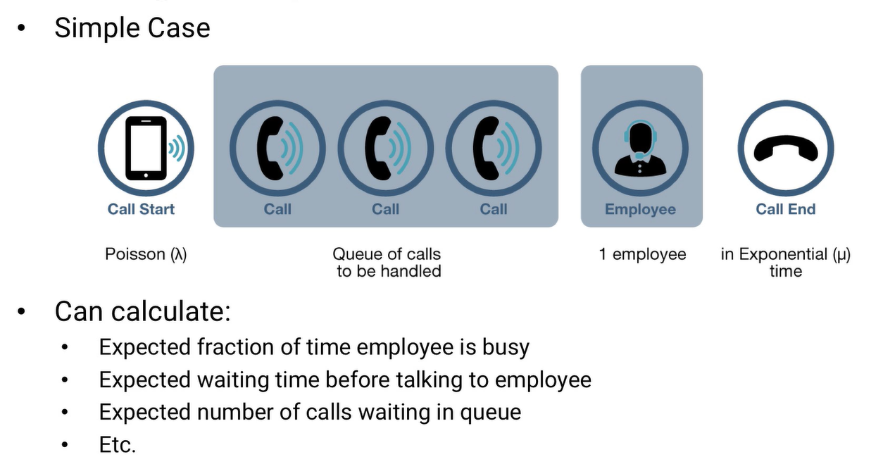

How we can calculate the above is by the below parameters

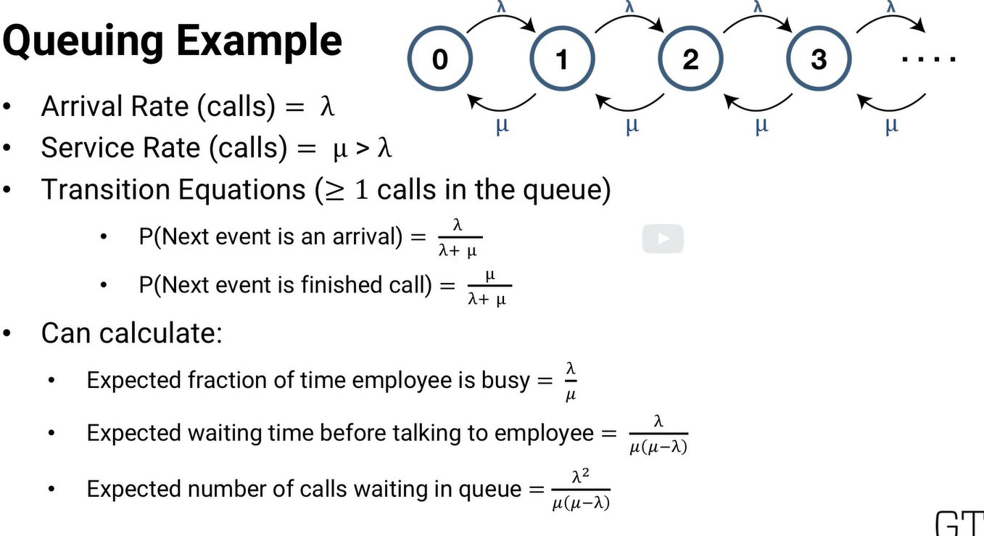

However many calls there are, new ones come in with rate lambda, and the current call being taken is finished with rate mu.

We can write transition equations, and solve them all simultaneously.

**Sample#2:**

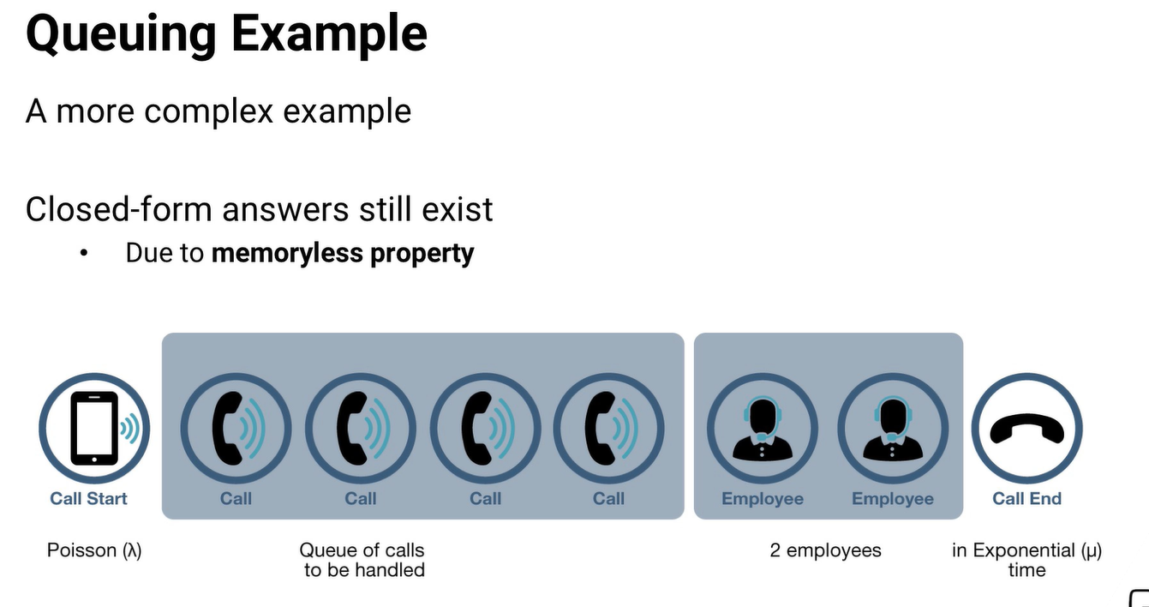**-as more employees, the calls finish sooner**

**More scenario:** suppose we only have capacity to have four calls in the system at once.

ALL CASES provide **closed-form answers** (Because of memoryless property of the Poisson and exponential probability distributions)

## memoryless probability

- means that it doesn't matter what's happened in the past, all that matters is where we are now.

- In the exponential distribution, it doesn't matter how long an employee has been on the phone. The distribution of the **remaining call time is exactly the same**.

-purely a **property of the exponential distribution**.

-It's not something we need to know beforehand about phone calls.It's something we can discover, by finding the call time distribution.

If the distribution of phone call times fits the exponential distribution? Then it means we've discovered something about phone call time, it's memoryless.

* The Poisson distribution is also memoryless, because it's related tothe exponential distribution
* So if we find that the arrivals of calls to the queue fit a Poisson distribution,we know they're memoryless.
* Other way,If we're wondering whether something might fit the exponential distribution, and we know that it's not memory-less? Then we know it won't be exponential.

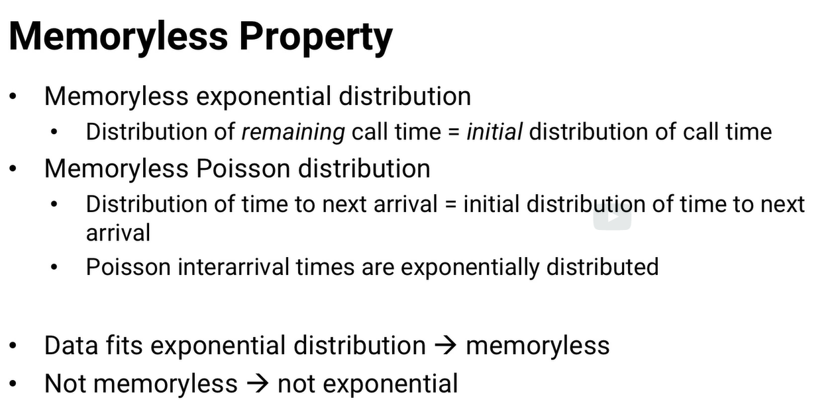

Example:

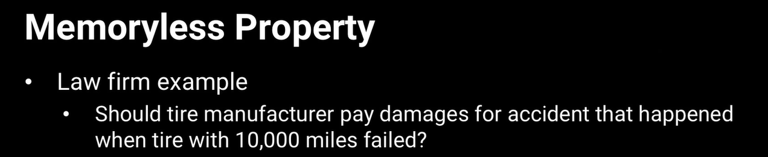

Approach: first determine how likely it is for a tire to fail at 10,000 miles,

* Was the tire defective, or is it normal-enough tire behavior?
* We can try to answer that question by modeling tire failure.

Tires are more likely to fail, the more worn out they are, so the expected mileage that a tire fails at is not memoryless.

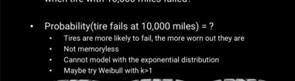

## kendall

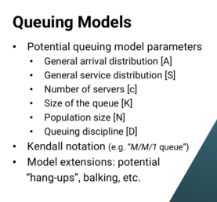

there are lots of complexities we could add to generalize it.

Parameters

1. The arrival distribution of calls (A)
2. service distribution (S) - the rate at which calls are answered
3. number of servers- number of people answering calls,
4. size of the queue.
5. population size - the number of people who can be called
6. queuing discipline. - whether the first call to arrive is the first one answered, or whether there's a different strategy.

There's a standard notation for this, called **Kendall notation**.

There are Kendall doesn’t support.But some additional Kendall extensions below..

**Hang-ups:** some people might hang up the phone, if they've been waiting too long for one of our employees to talk with them.

**Balking:** if you imagine a queue where people see how many others are in line ahead of them, A person might think there are too many people, she'll have to wait too long, and she'll leave without buying anything. That's called balking, and it can also be incorporated.

**Challenges :** once we start moving away from an easy-to-analyze probability distribution. And we start adding more and more complexities, the math gets **very difficult**.

**Suggestion:** In these sorts of cases, we can use a tool called simulation instead..

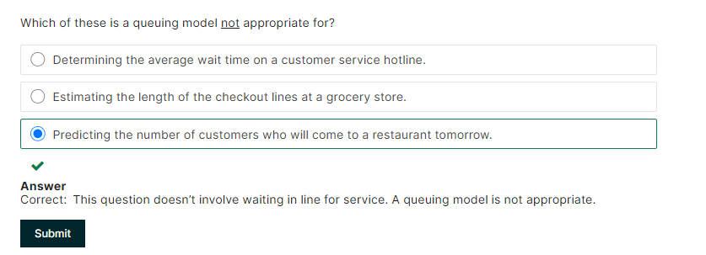

# 9.10 Simulation basics

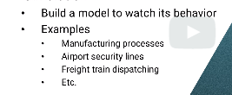

**Example1**:

1) we could express the steps of the manufacturing process mathematically,

2) code it in a programming language,

3) run the code and observe how the process works.

more examples

* we could do the same with an airport security process, nationwide freight train dispatching, or almost anything else.

## 9.10.1 Types of Simulation

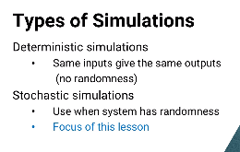

-In stochastic , we can get different outputs each time we run a model due to randomness

In this course, we are going to see stochastic model(more useful)

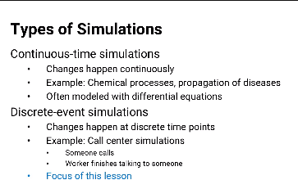

## 9.10.2 Discrete event simulations

-useful for prescriptive analysis

-used in systems with lot of randomness

-with systems with high variability, using average values like in optimization model isn’t good enough

### Example1: Semiconductor manufacture process

1) On average, wafers arrive at the machine every 20 seconds

2) average they take 19 seconds to process.

All goes good => each new wafer arrives exactly one second after the last one is finished, and the process never has any delay.

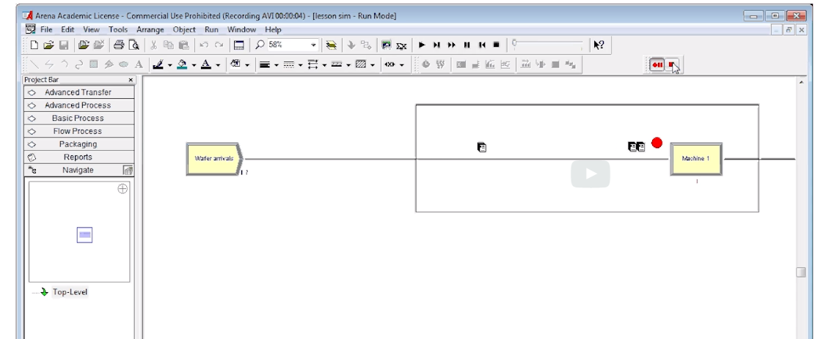

If some variability => it looks like below simulation

1) arrivals are poisson, still with an average of 1 every 20 seconds,

2) manufacturing time is exponential, still with an average of 1 every 19 seconds.

As you can see, there's sometimes a very large queue building up.(On average, there will be about 19 wafers waiting to be processed.)

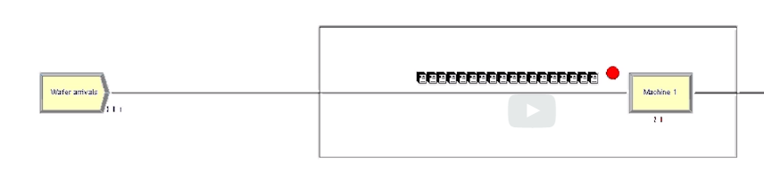

Simulation software : **Arena**

### Example2: Airport baggage

Red => baggage ; Blue => airplans ;2 concourse with 30 gates

**purpose**

- help decide how many baggage tugs were needed

- where they should be located to ensure that arriving bags were moved quickly

both from planes to baggage claim for passengers coming into the city, and from one plane to another for passengers making connections.

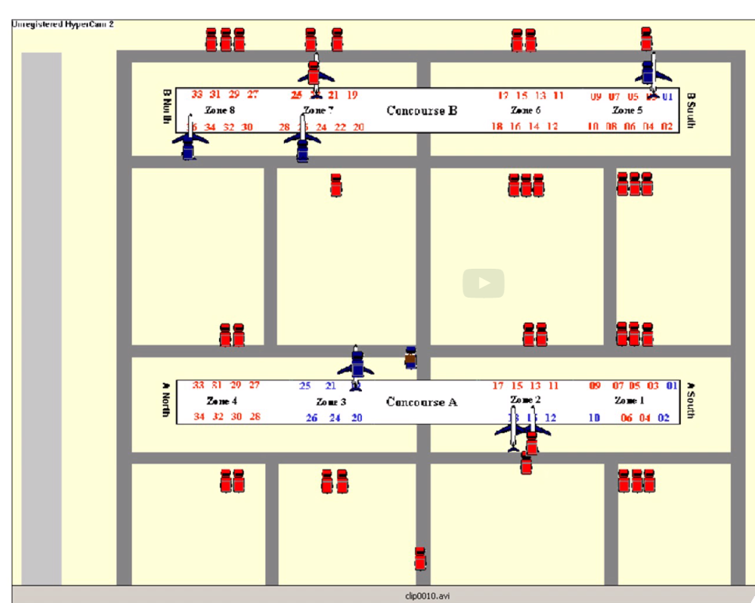

### Example3:cancer center

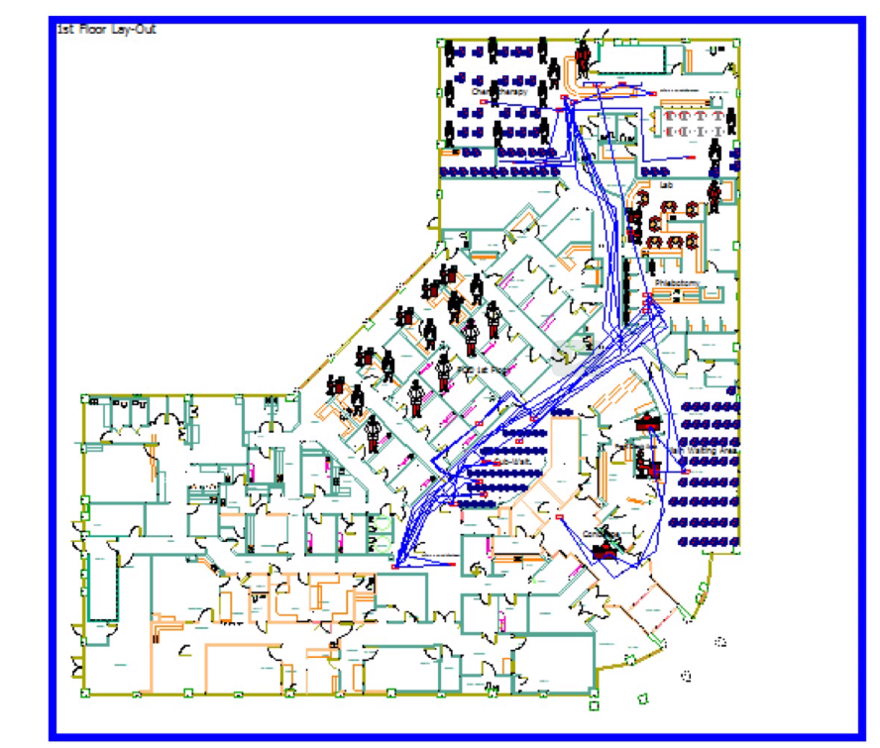

-above has hospital floor layout, medical attendants, waiting area

**Purpose:**

- determine the right mix of workers, that patients wouldn't have to wait a long time.

- determine the right amount of physical resources. say, is the number of examination rooms too low, too high?

### Example4 : Airline global flight network

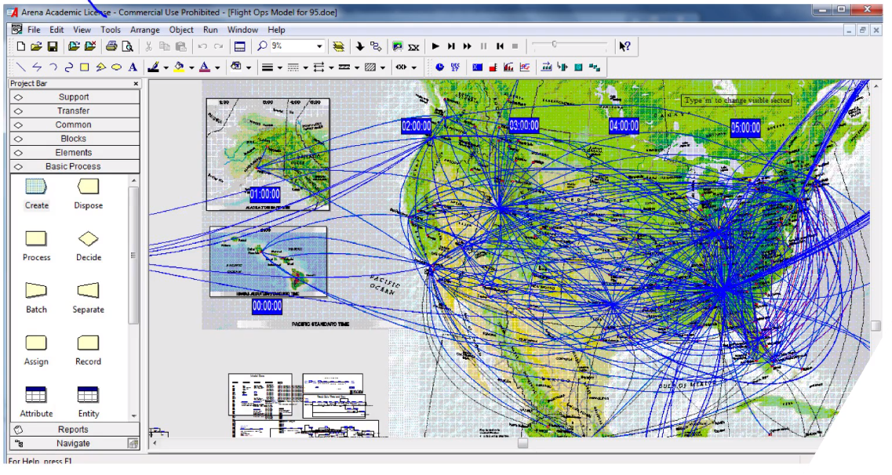

**Purpose:**

- help the airline react to disruptions.

say, If there's a bad storm that causes a major airport to shut down fora few hours,

- what's the best way for the airline to reschedule its flights to cause minimum disruption to its passengers, crew, and overall operations

## 9.10.3 Components of simulation

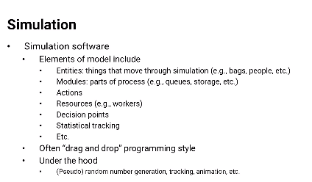

- create and connect elements to represent each piece of the system,

- when appropriate, specify the associated probability distribution or decision role associated with each.

## 9.10.4 Challenges

**1) Pseudo random**

- they just generate numbers that might appear random, called pseudo random.

- And they shouldn't use numbers whose non random properties,especially lack of independence, lead to incorrect outcomes.

when coding simulation ,keep in mind

1. **Replication**

* Cannot run software once and decide
* Need to run multiple time and get distribution of several outcomes

**Example**:

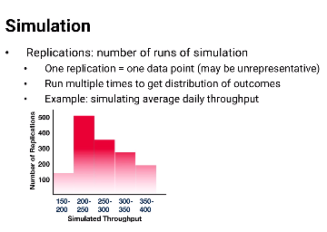

- plot the distribution, find the average throughput, find the variance in the throughput, etc., and use that information in your overall analysis.

## Validation

**example1**

- simulation shows an average daily throughput of 250 wafers,

- but the real production facility has an average daily throughput of just 100

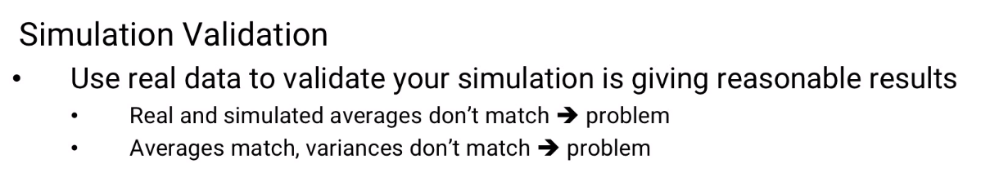

then your model probably is not a good reflection of reality.

**example2**:

- simulation shows a throughput distribution (right) and the real facility has a throughput distribution like (right graph)

then your model still is not a good reflection of reality even though they have about to same average.

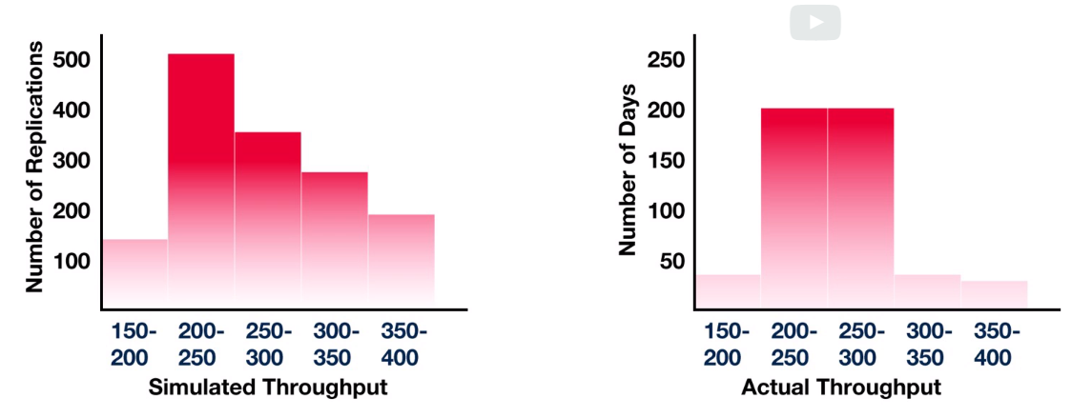

**Suggestion:** So don't just look at the average, make sure the variability is about the same too.

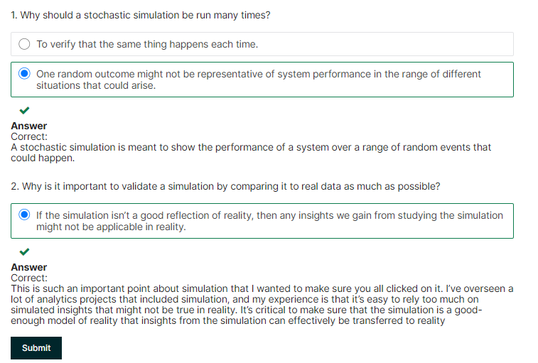

# 9.11 prescriptive simulation

- simulation good for answering what-if sort of questions

-one simulation is validation, we can go ahead and use it

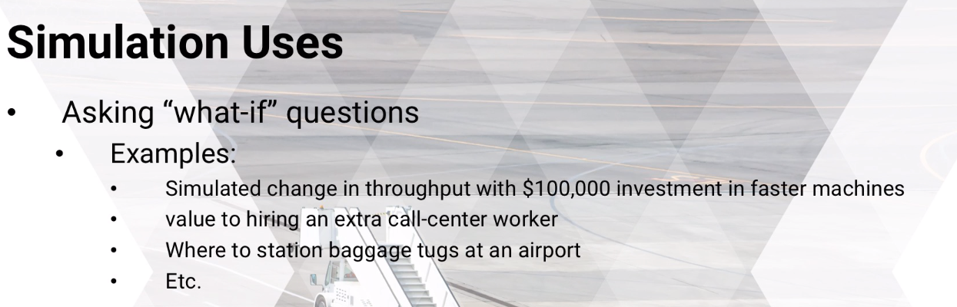

-we can compare results of many options to see what is the best course of the action is

- simulation can do heuristic optimization of a set of parameters.

For **example**, on a huge manufacturing facility with hundreds of steps, what's the best buffer size to have at each step of the process?

-automated optimization is helpful, but lets see comparisons by hand

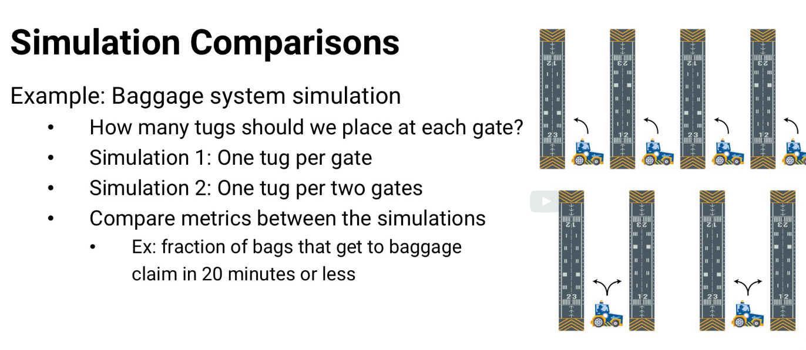

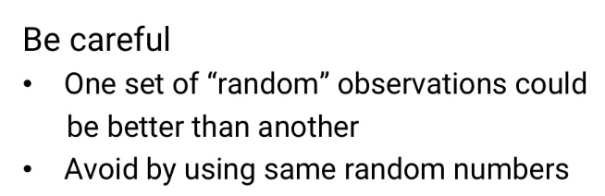

**Challenges:**When comparing, we are faced with the question , if one set of data points better than the other

- requires its own statistical analysis.

- basic test to see whether the means are different for example, but we might be able to do even more.

**Non parametric test**

* on 1st replication of each simulation, we use the same random numbers whenever possible.
* for second replication of each,the two simulations use the same random numbers as each other.
* And so on. The Ith application of each simulation uses the same random numbers

Then its like having a thousand different scenarios, and for each scenario we can see which method is better and see how often one is better than the other.

This sort of nonparametric test can give you valuable information.

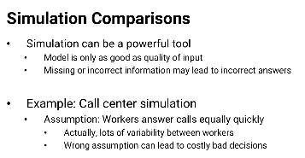

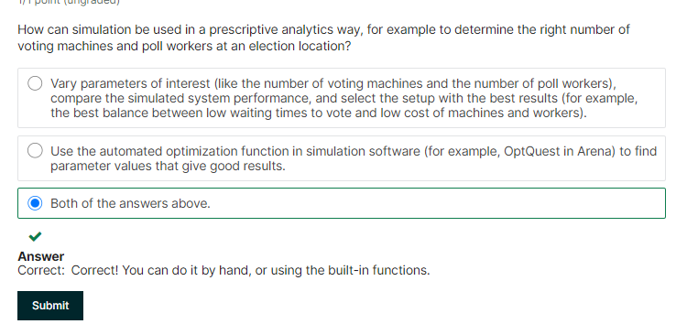

# 9.12 Markov Chains

-probability based analytical models for making comparisons

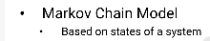

**Example**: states of the weather(sunny, cloudy, etc..)

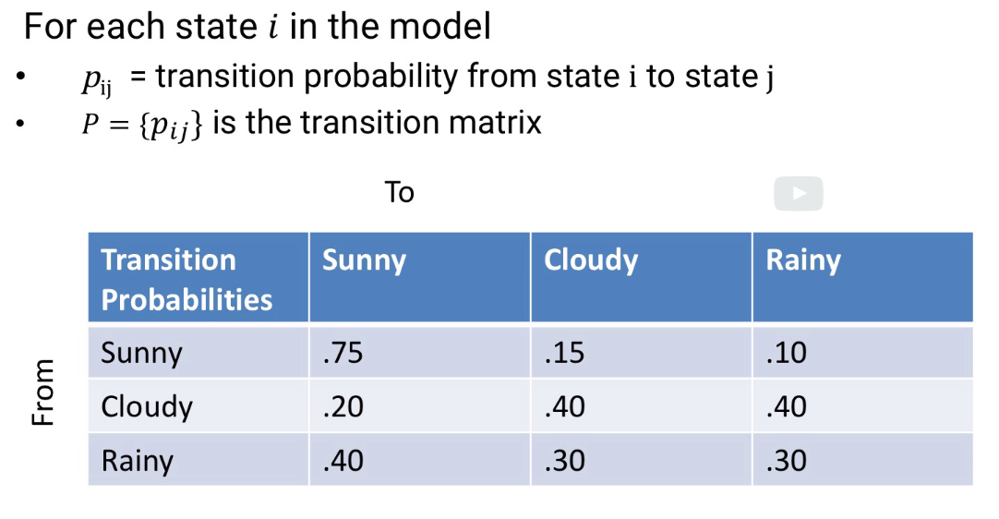

**Math:**

* vector pi that shows the probability that the system is in each state.
* Pi*p is probability of the state tomorrow

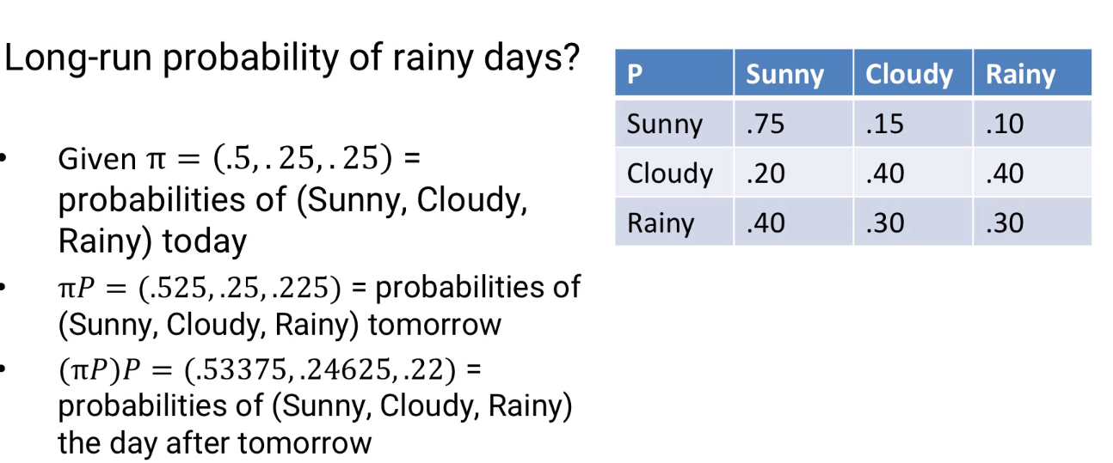 -All these answers depend on initial probability vector “pi”

## Steady state

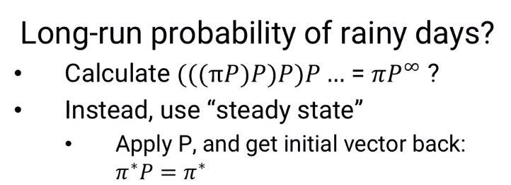

* In steady state, the probability of being in state i is the same every day.
* So if we apply the transition matrix by multiplying pi by P, we'll get our vector pi back again.The probabilities are the same.

We can find steady state probability “pi*”

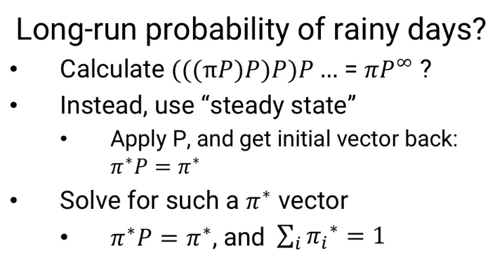

Note, there is not always a steady state

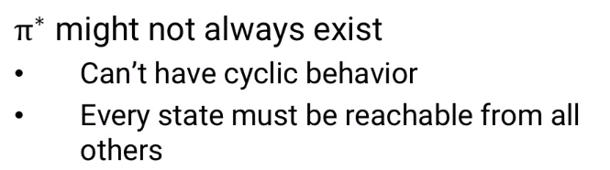

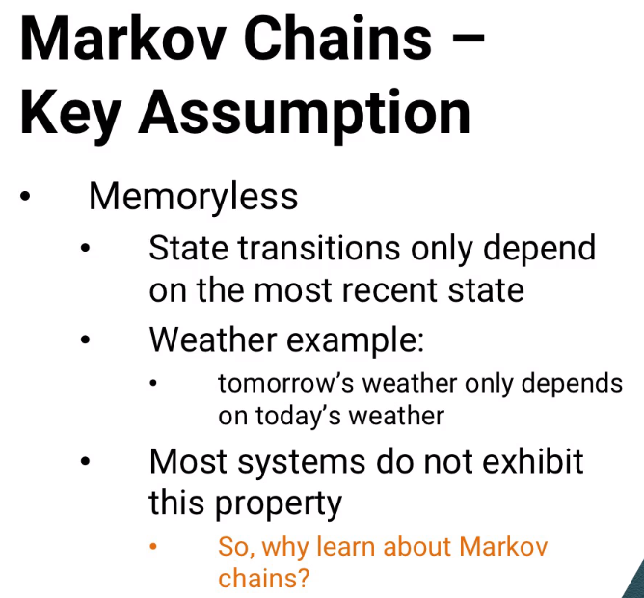

* Most real time cannot be memory less

**Why useful?**

-use smaller amount of information to connect larger ones

**Example:** web search (google web search)

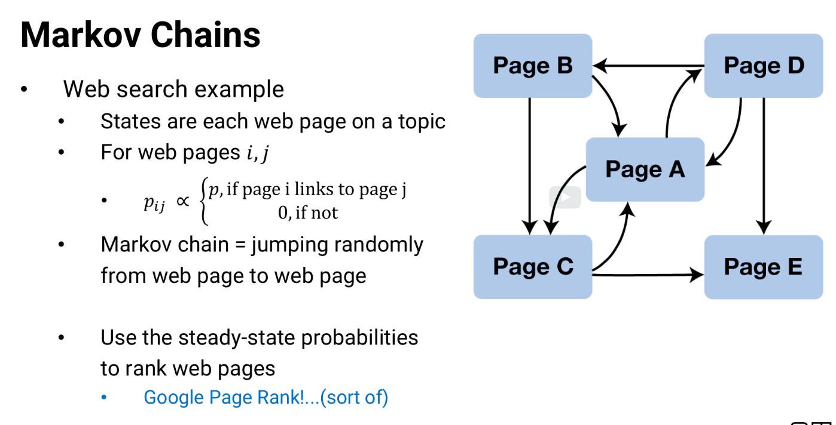

## Page Rank System

* most page will not link to each other.so mostly transition matrix is zero
* Wcan use the transition matrix to see what happens if we start at a Markov chain page and iteratively jump from one page to another using the available links.Choosing a link at random and following it, choosing a link from that page and following it, etc..
* Only among Markov chain webpages,By finding the steady state probabilities, we'll discover which Markov web page we would be at, most often, second most often, etc,
* And we could use that order as a ranking on the webpages.

**Basic idea of how Google ranks webpages for searches! It's called the Page Rank System.**

Complexities built in

- some for mathematical stability,

- some as heuristics to make the results a little better,

- some to avoid having people game the system with search engine optimization.

* **professor research:**

- rank college basketball teams as part of the RMC ranking method

* **Other Examples:**
* model urban sprawl
* population dynamics,
* - and disease propagation, applications where the memoryless property

## Summary

* => used where memoryless is important in the short run but not so important in the long run.
* => Overall, Markov Chains are not the most commonly used analytics methodology, mostly because of the limitations of the assumption that the system is memory-less.
* => Especially because there aren't many good substitutes for Markov Chains in the instances where they really do work well.

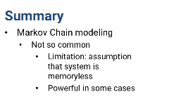

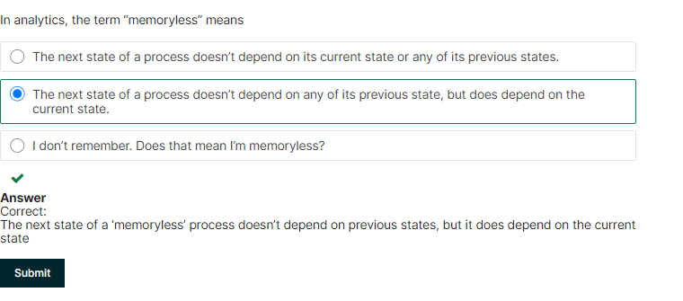

1.